**Inverse Square Law**

**B1**

Newton’s Law of Gravity

Any two bodies attract one another with a force proportional to the product of their masses and inversely proportional to the square of the distance between them; the magnitude of the force of attraction between the two masses is



where *G* is the universal gravitational constant

Vector notation



Force on *m*2 due to *m*1

**

*m*2

**

**

*m1*

**

Assumption: point masses

**B2**

How did law of gravity work so well for planets?

We are trying to describe a force NOT a shape or volume

🡪 If the gravitational force for an actual body (made up of an infinite number of particles) can be written as the force for a point mass, then it is a point mass for gravitational purposes, regardless of the actual physical dimensions

Planets fit well into a particular subset of centrobaric bodies; it is easy and valid to model planets as “spherically symmetric”

spherical and of uniform density or density that varies only with distance from the center (so density is constant in thin concentric spherical shells)

“Spherically symmetric” body produces same gravity force (on an outside point) as a point mass

**Theorem:** attraction of a homogeneous spherical shell on a unit mass at an outside point is the same as that of the mass of the shell concentrated at the center of the sphere

**B3**

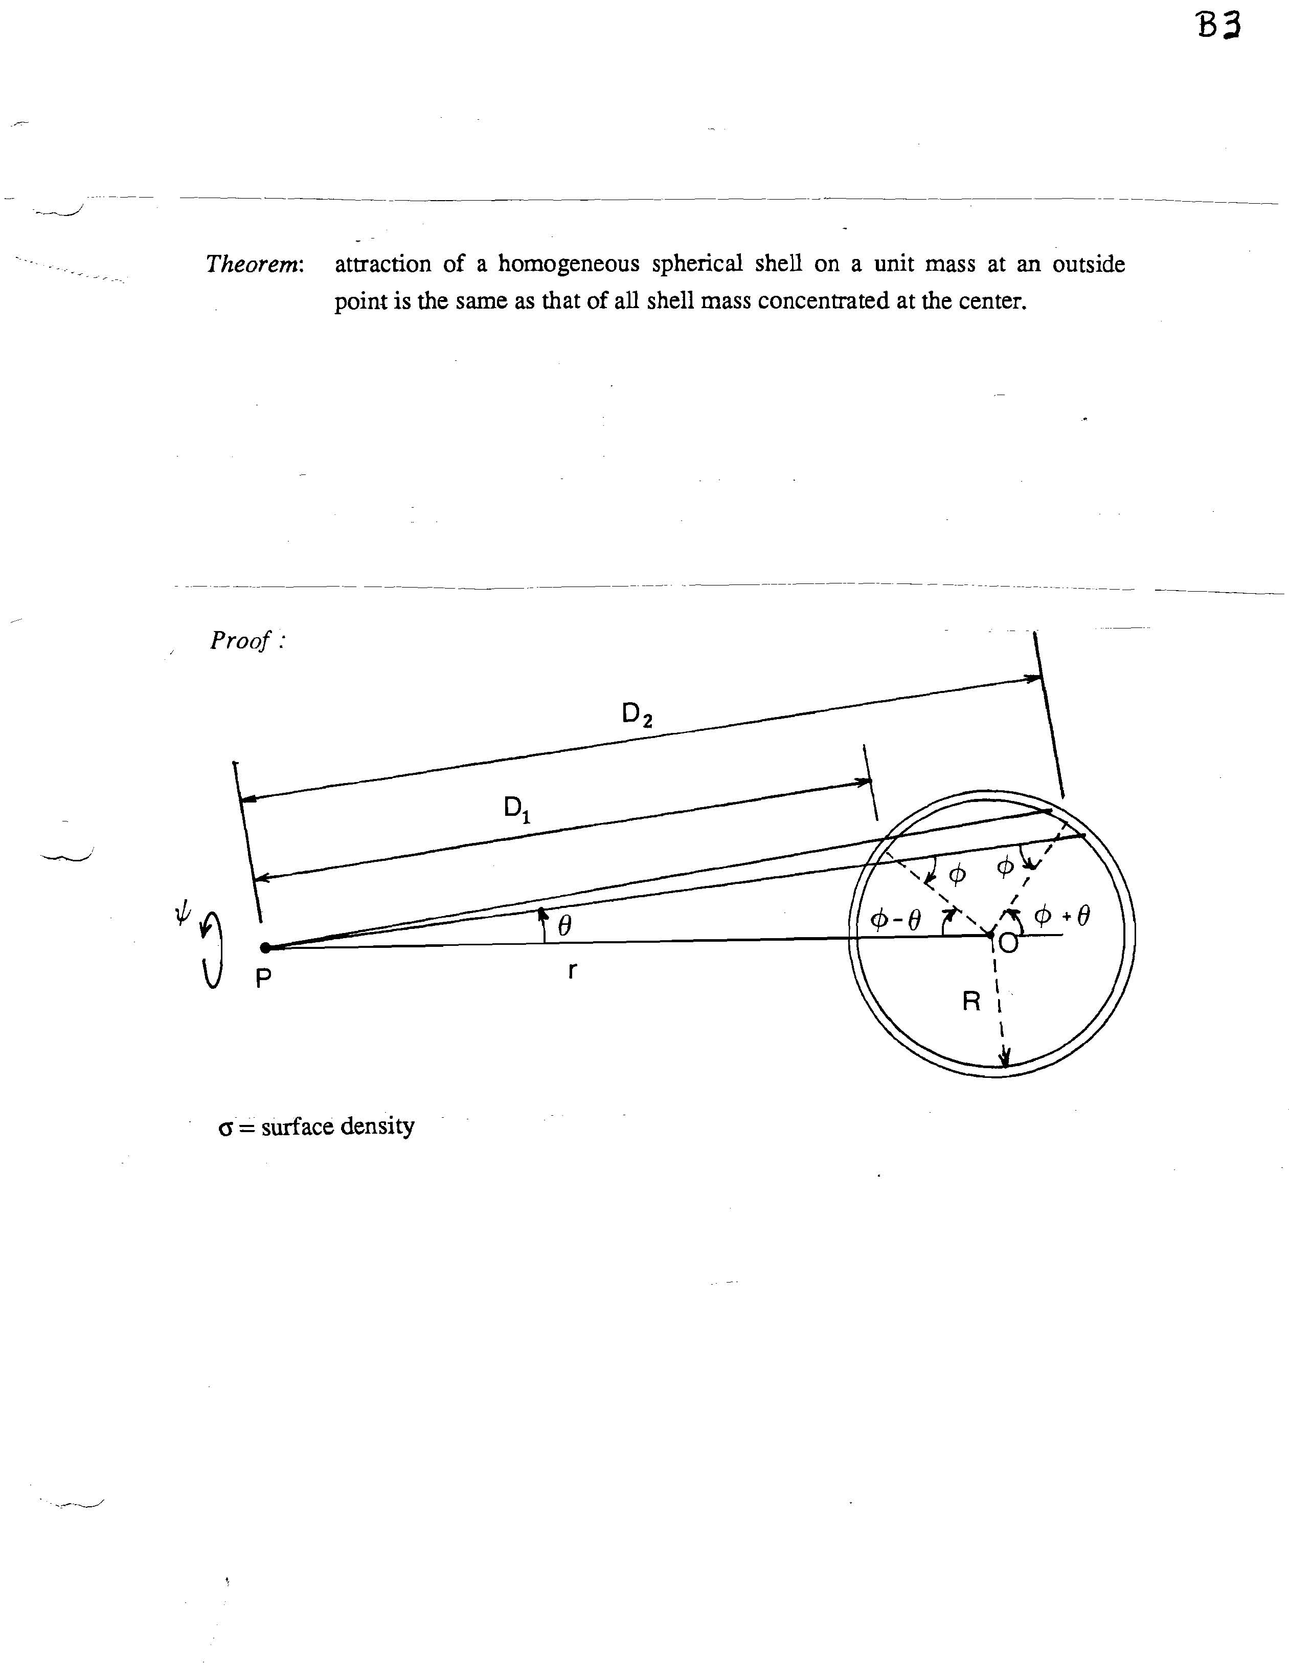

Total attractive force on mass at *P* toward *O* is sum of forces acting on each differential surface element on the shell:

**B4**



= 

= 

(For a point *P* inside the shell the two terms in the double integrand have opposite sign and cancel 🡪 the attraction at an inside point is zero.)

By geometry

 and 



= 

= 

**Corollary:** The attraction of any “spherically symmetric” mass distribution at an outside point is the same as that of all the mass concentrated at the center.

(Planets are not actually spherical or homogeneous, but good approximation for preliminary calculations.)